THE FORGOTTEN FLEET

By Peter J. Bayliss

AB2996 - INBOUND TO VANIMO FROM MADANG

(AITAPE 12 MILES ABEAM - NEW GUINEA 1965)

Dedicated to the history and memories of
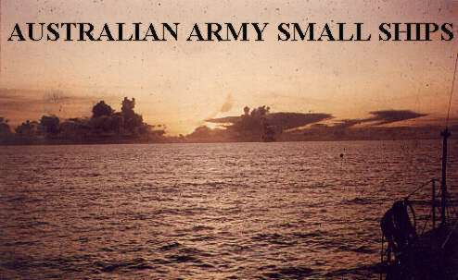

Australian Army Mariners
of WW II, Japan, Korea, Borneo, Vietnam and New Guinea.

by

Peter J. Bayliss

TRANSPORTATION (Royal Australian Engineers)

The Australian Army's experience with Marine Craft / Vessels began during WW2 (1941) in Tobruk Harbour with the forming of a docks stevedoring unit and grew from that small unit.When Japan began the Pacific war The Ist Australian Water Transport Group was formed at Chowder Bay, Sydney. All Water Transport units were part of Royal Australian Engineers Corps. By 1945 two Water Transport Groups were active. As well as vessels and craft impressed from their civil owners from 1942 there were many 'Purpose built' vessels already in service with more building and more on order. The smallest operated craft were the AD*** launches of 14' LOA and the largest was the AV2767 "CRUSADER" of 200'LOA, which was not completed until 1946.

The estimated number of vessels operated by the Australian Army Transportation Service (RAE) in 1945 was 1800+. Vessels of the service had served in New Guinea, New Britain, Bougainville and Borneo and despite terrible conditions (Environmental, Climatic and Operational); every mission given them was carried out successfully.

At the conclusion of The Pacific war the numbers of craft and personnel were reduced dramatically. Some of the larger vessels were employed on War Graves duty and ammunition dumping duties but many were scuttled in situ particularly at Labu Lagoon, a few miles South of Lae - New Guinea.

Transportation (RAE) craft accompanied the Occupation Force to Japan as the 58th Port Craft Co. When the Korean War began some small craft (40'W/boat) were based at Pusan and Inchon. The unit became Britcom Transportation Squadron and comprised Australian and British Personnel with the Australians handling the craft and the British handling the Docks operation. Meanwhile................ Back on the Farm........

The Interim Army began in 1947 and that same year Water Transport (an unwanted legacy from the British ie. Inland Water Transport) was rather active despite its small number of personnel. In 1949 personnel from Chowder Bay along with other members of the Armed Services worked the Coal fields during the 'great coalfield strike'. Transportation (RAE) at this time had as well as the Maritime arm, Movement Control, Railways and Port Construction.

In 1951 the 300 ton (WCV) AV1379 "TARRA" began its 10 year Logistic Resupply of Army units in New Guinea. In 1954 the Federal Government granted Military Aid (Weapons, Munitions clothing and food) to the French Forces fighting in Indo-China. The ship to be loaded with this aid, SS "RADNOR" was blacklisted by the Sydney maritime unions and consequently personnel from Chowder Bay manned the ship's winches in order to load the ship. Unfortunately Dien Bien Phu fell while the ship was en-route to Vietnam and nobody has heard of the ship or the cargo since. By the end of 1956 Britcom Tn. Squadron in Japan was deactivated ending our presence in Japan/Korea.

In 1959 a high speed 62' Command Craft AM2834 "FERN" was allocated to New Guinea for coastal duties with Area Command and Pacific Islands Regiment. At this time Transportation Personnel were serving in New Guinea, all of the Reserve Transportation units in NSW, Qld, Victoria and Western Australia as well as the National Service Battalions and Darwin. The entire strength of Transportation, including Movement Control was no more than120 personnel.

During 1958 a proposal was made to Army to purchase Landing Ships capable of transporting the Armoured Corps Centurion tanks as at that time the 52 ton Centurions were based at Puckapunyal in Victoria and means of moving the tanks was near impossible. The Navy did not possess an amphibious capability. Four Landing Ships Medium (LSM) were purchased from the US Navy in Japan and all four ships were sailed back to Australia by Army crews by early 1960 and the unit to operate them was 32 Small Ship Squadron. As a consequence of obtaining the four LSM's the number of personnel within Transportation (RAE) was greatly increased.

In 1961 two ALC-50's were built in Tasmania. The design of, and the finished product left much to be desired. The primary function of these Landing Craft was to put a Centurion tank on a beach. This, at no time during their 13 years of service, was ever realised. They were eventually modified and sent to New Guinea where they served well on Logistic re-supply and other duties. During 1965 a 1400 ton Cargo Ship "MARRA" was purchased and renamed AS3051 "JOHN MONASH".

The four LSM's all served in Vietnam and did quite valuable service for both the Australian and US Forces. The "JOHN MONASH" provided a shuttle service from Australia to Vietnam transporting cargo for the Australian Task Force. The unit which operated the five ships, 32
Small Ship Squadron was disbanded in 1971 due to the economical life of the ships being reached.

Also included is a section on the MOBILE RIVERINE FORCE . This force was a combination of the US 9th Infantry Division and the small and little ships of the US Navy who fought a different war in Vietnam. It is not known by Australians and few Australian Vietnam Vets have ever heard of it. It operated "in country" from 1967 to 1971 and was not only a large operation but also very efficient in its type of warfare. The section is not a unit history but rather a photographic view of the craft and ships employed in Vietnam. AV1356 "CLIVE STEELE" carried quite a few cargos to its Land Base at Dong Tam on the Mekong River and I spent a couple of weeks there in 1969.
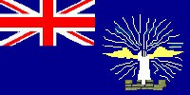

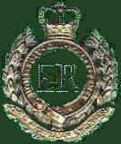

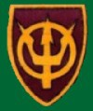

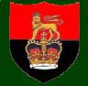

The topics covered are:
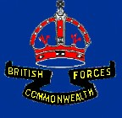

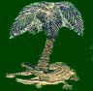

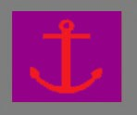
WW2 UNITS | AV TARRA | BRITCOM Tn. SQUADRON | NORTHERN TERRITORY COMMAND | ALC-50-AB2996 | AM2834 "FERN"
1939-45 | 1946-1965 | 1956 | 1957 - 1961 | 1961-62 | 1963 - 65
SW PACIFIC BORNEO | NEW GUINEA | JAPAN | NORTHERN TERRITORY | TASMANIA - CAPE YORK | NEW GUINEA
32 SMALL SHIP SQUADRON | US ARMY VIETNAM | PNG Tn. SQUADRON | PNGDF LANDING CRAFT SQUADRON | MOBILE RIVERINE FORCE | TRANSPORTATION CENTRE
1965-69 | 1969-1970 | 1971-73 | 1973 - 1975 | 1967-1969 | 1947-1975
NEW GUINEA - VIETNAM | VIETNAM | NEW GUINEA | NEW GUINEA | VIETNAM | SYDNEY

